Wall type 1

Reconstruction | 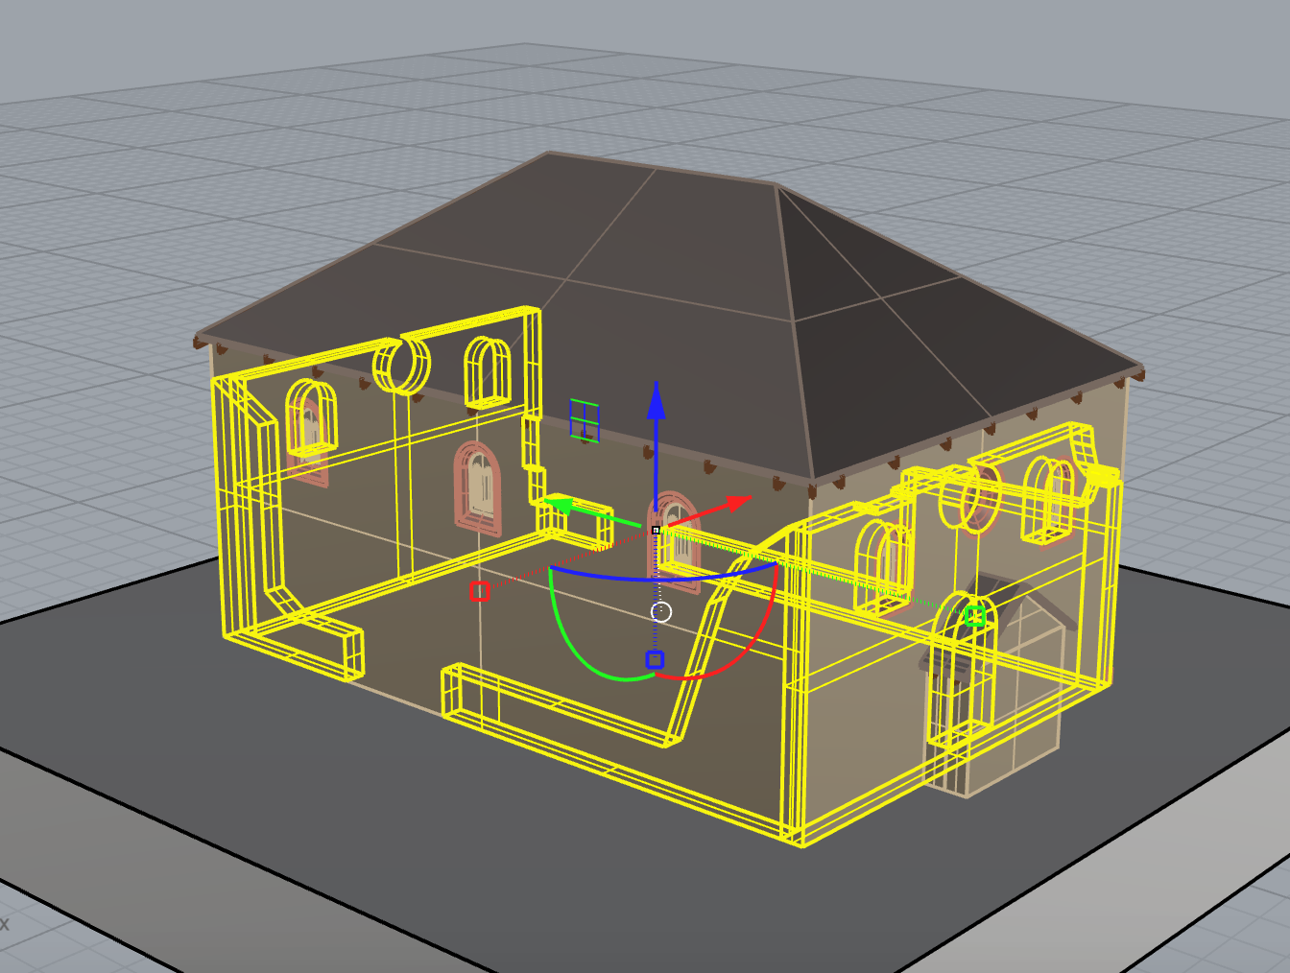
Used sources | report_05.jpg | 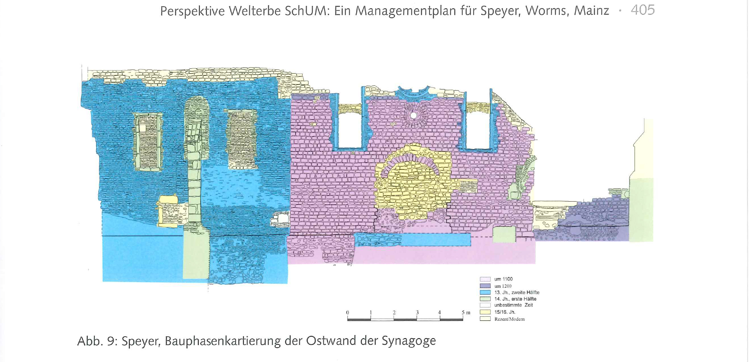
 | photo_location_01.jpg | 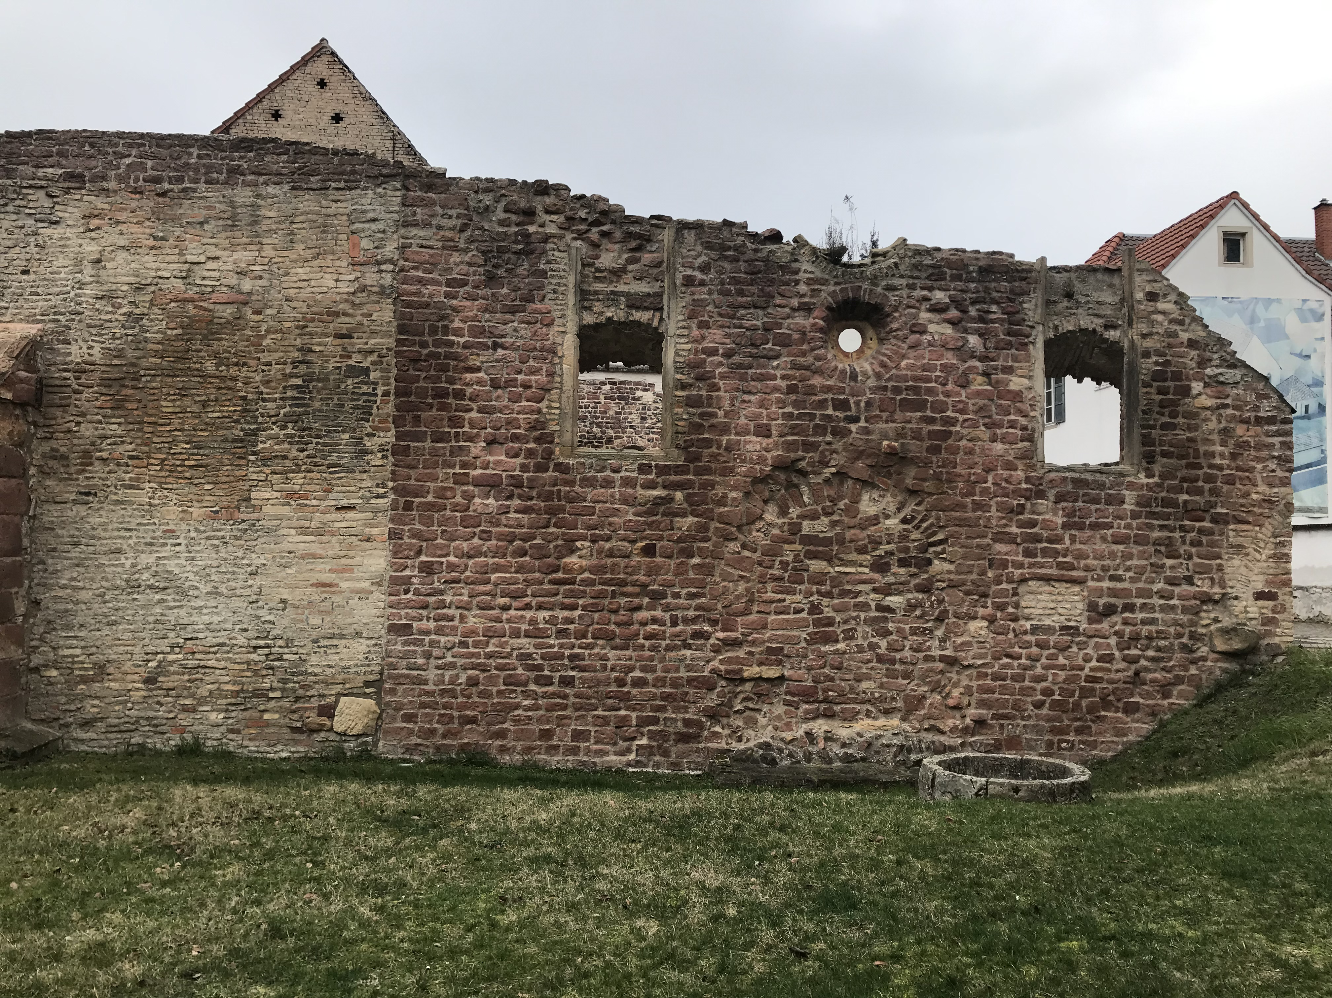
Uncertainty | This is the part of the wall that we can still see | 04-still existing
Argumentation | The still existing part of the wall was cut from the volume of the perimeter walls according to the sources. The elevation done following the archaeological excavations (“report_05.jpg”) was imported into Rhinoceros, scaled and used as the basis to trace the cutting surface.

Wall type 2

Reconstruction | 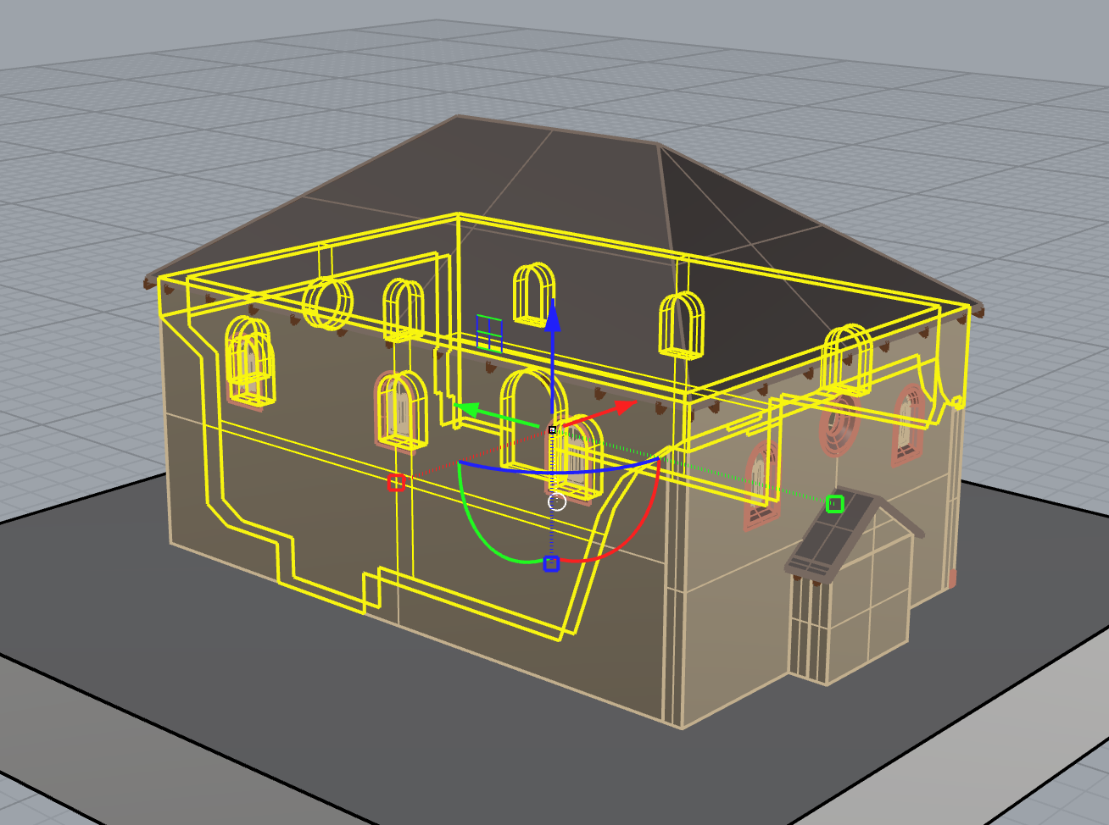
Used sources | Name of the source,  eg. Photo_location_01 | Screenshot of the source
 | Name of the source,  eg. Photo_location_02 | Screenshot of the source
Uncertainty | This part of the wall was reconstructed by deduction, assuming that it was similar to the still existing part | 03-deduction
Argumentation | Short description of the process of reconstruction with enlightening the challenging part of reconstruction of element

Window type 1

Reconstruction | 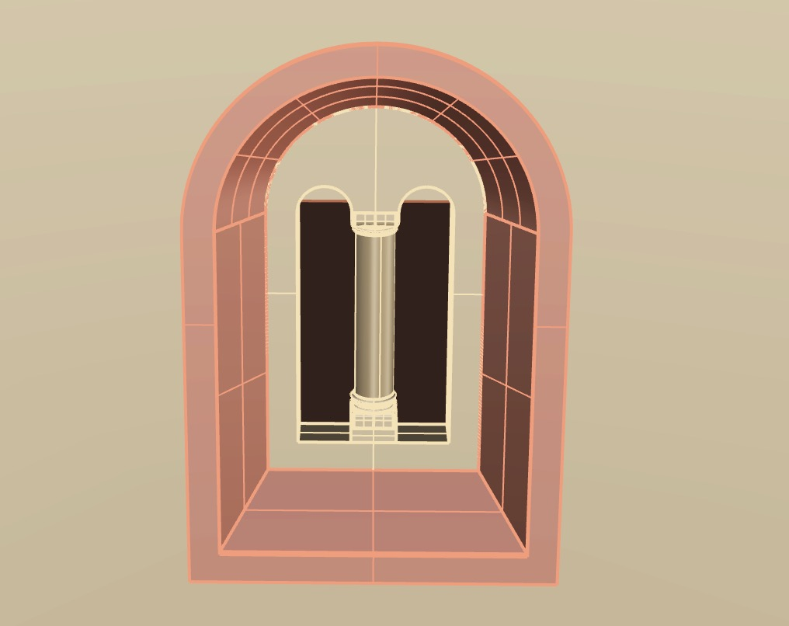
Used sources | photo_location_04.jpg | 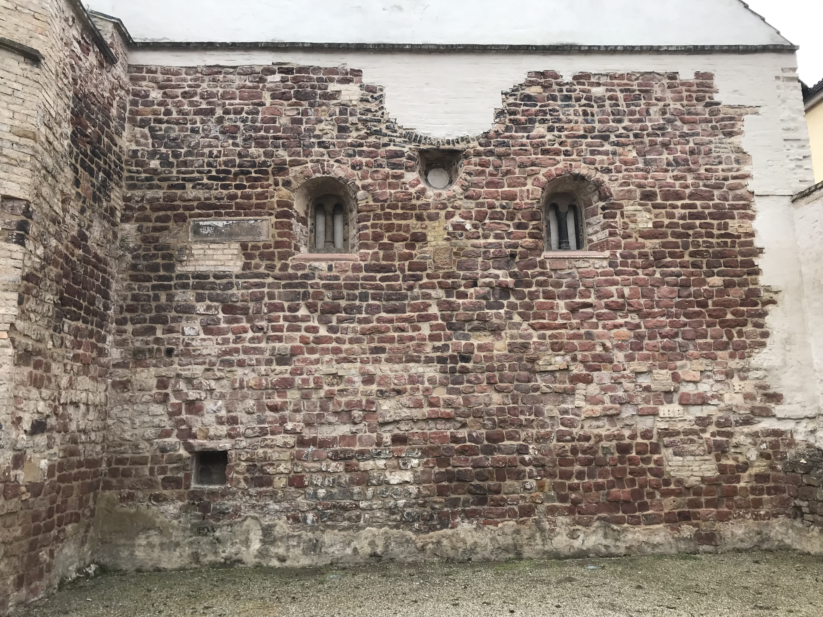
 | photo_museum_02.jpg | 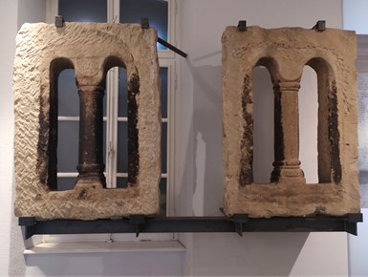
Uncertainty | The windows on the western façade are copies of the original ones preserved in the Judenhof museum, thus in that case the uncertainty level is “04-still existing”. It is assumed that the other windows were similar and can be reconstructed by deduction. | 04-still existing  for those on the western façade; 03-deduction for the other ones
Argumentation | The windows were reconstructed starting from the original ones preserved in the museum and the copies located on the western façade

Window type 2

Reconstruction | 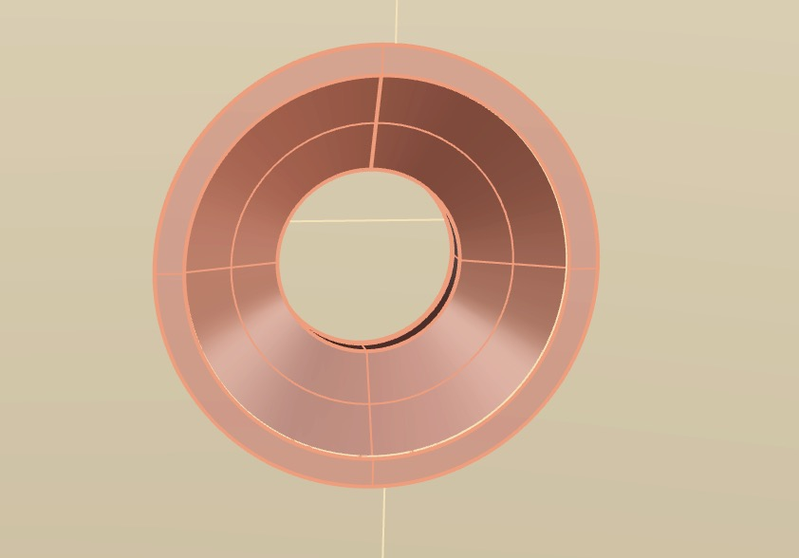
Used sources | Name of the source,  eg. Photo_location_01 | Screenshot of the source
 | Name of the source,  eg. Photo_location_02 | Screenshot of the source
Uncertainty | We can see a fragment of the circular hole in the still existing part of the wall: it is completed by deduction | 03-deduction
Argumentation | Short description of the process of reconstruction with enlightening the challenging part of reconstruction of element

Portal

Reconstruction | 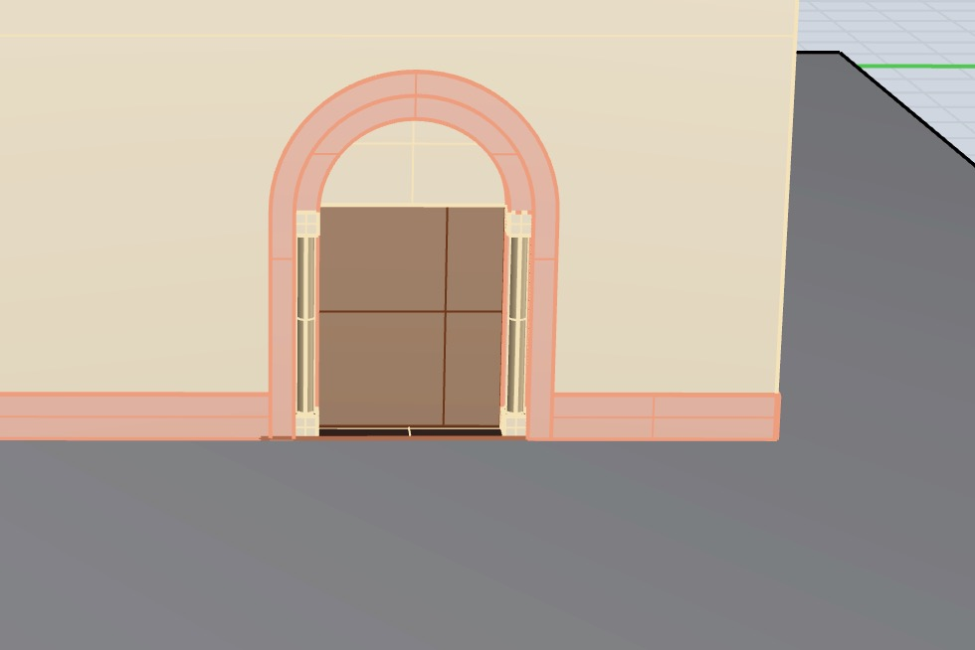
Used sources | analogy_02_01.jpg | 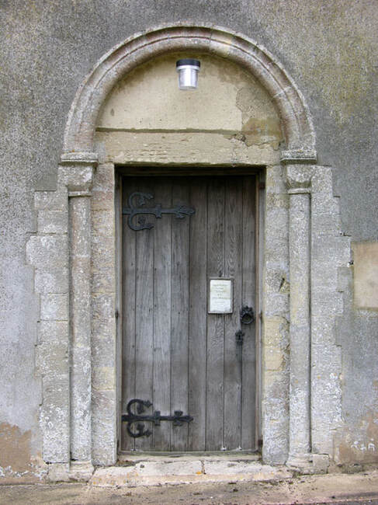
 | analogy_03.png | 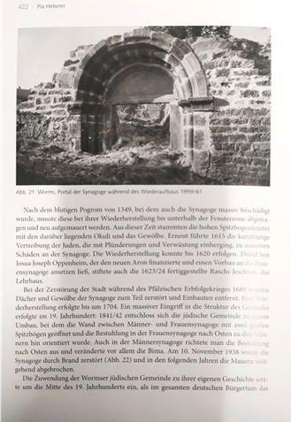
Uncertainty | We do not have traces of the portal of the Speyer synagogue, but we can reconstruct it by analogy e.g. with the portal of the medieval synagogue in Worms | 03-analogy
Argumentation | Short description of the process of reconstruction with enlightening the challenging part of reconstruction of element
Beams

Reconstruction | 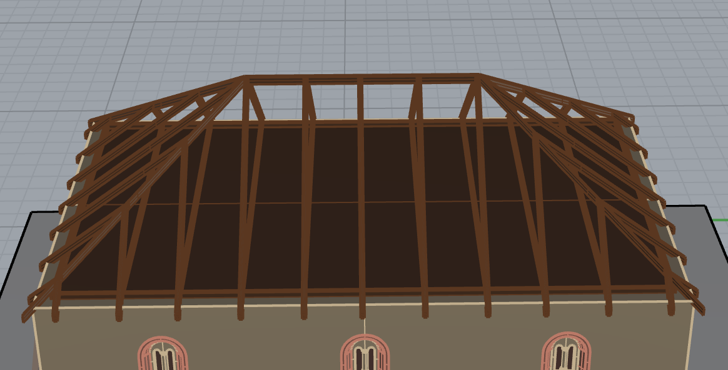
Used sources | Name of the source,  eg. Photo_location_01 | Screenshot of the source
 | Name of the source,  eg. Photo_location_02 | Screenshot of the source
Uncertainty | We know nothing about the structure of the roof | 01-hypothesis
Argumentation | Short description of the process of reconstruction with enlightening the challenging part of reconstruction of element

Ceiling

Reconstruction | 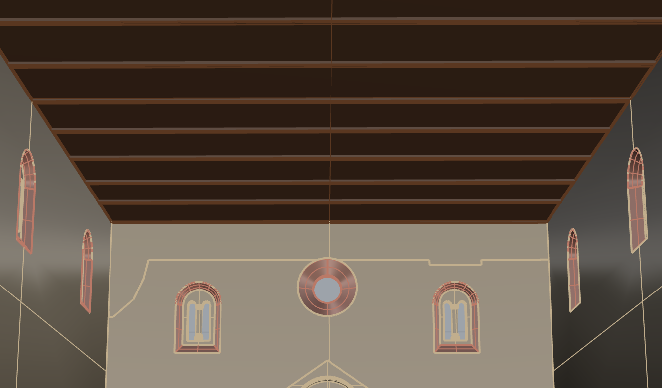
Used sources | Name of the source,  eg. Photo_location_01 | Screenshot of the source
 | Name of the source,  eg. Photo_location_02 | Screenshot of the source
Uncertainty | We know nothing about the structure of the roof | 01-hypothesis
Argumentation | Short description of the process of reconstruction with enlightening the challenging part of reconstruction of element

Roof type 1

Reconstruction | 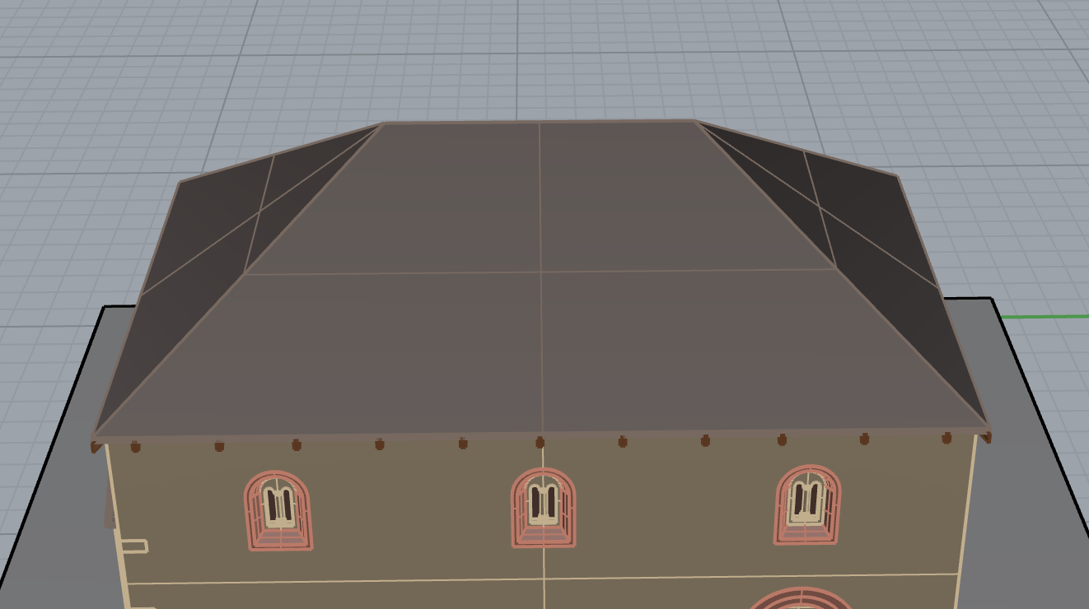
Used sources | Name of the source,  eg. Photo_location_01 | Screenshot of the source
 | Name of the source,  eg. Photo_location_02 | Screenshot of the source
Uncertainty | We know nothing about the structure of the roof | 01-hypothesis
Argumentation | Short description of the process of reconstruction with enlightening the challenging part of reconstruction of element

Roof type 2

Reconstruction | 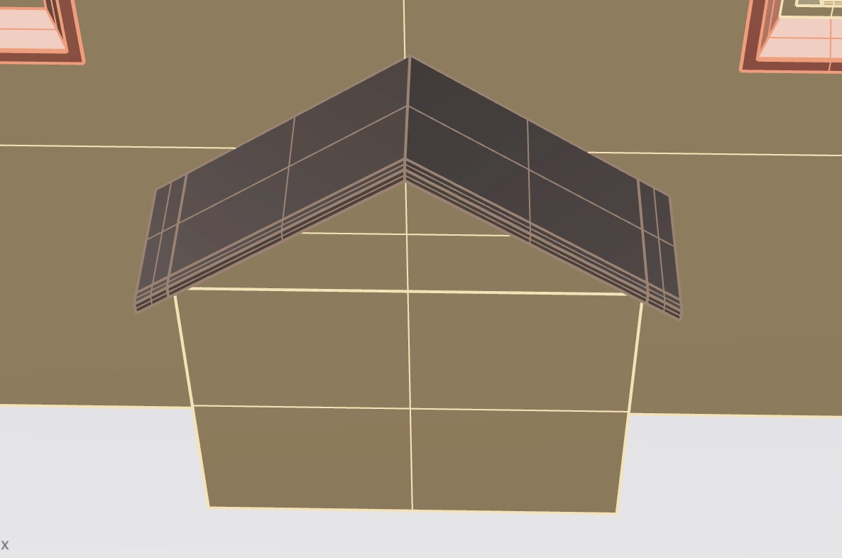
Used sources | Name of the source,  eg. Photo_location_01 | Screenshot of the source
 | Name of the source,  eg. Photo_location_02 | Screenshot of the source
Uncertainty | We know nothing about the structure of the roof | 01-hypothesis
Argumentation | Short description of the process of reconstruction with enlightening the challenging part of reconstruction of element

Aron Hakodesh

Reconstruction | 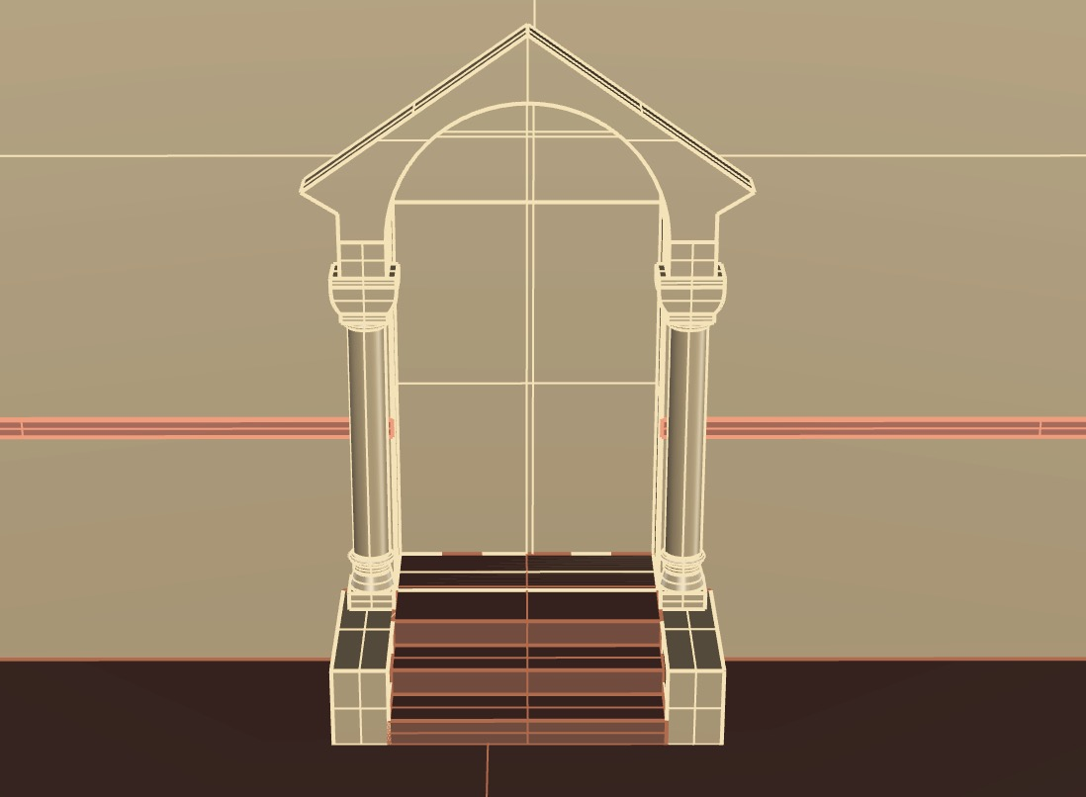
Used sources | Name of the source,  eg. Photo_location_01 | Screenshot of the source
 | Name of the source,  eg. Photo_location_02 | Screenshot of the source
Uncertainty | Argumentation | 03-analogy
Argumentation | Short description of the process of reconstruction with enlightening the challenging part of reconstruction of element

Cornice

Reconstruction | 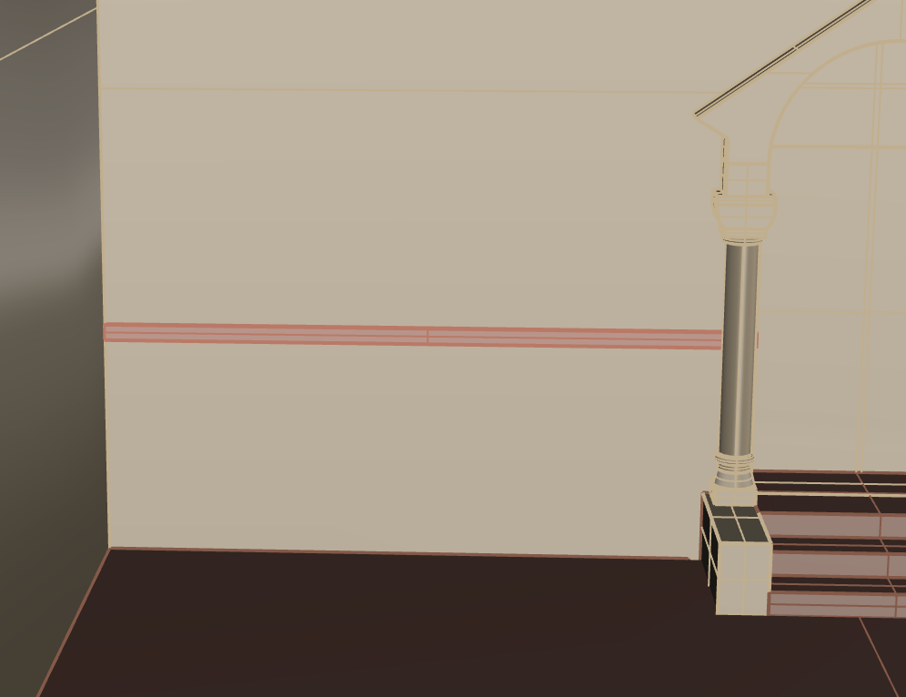
Used sources | Name of the source,  eg. Photo_location_01 | Screenshot of the source
 | Name of the source,  eg. Photo_location_02 | Screenshot of the source
Uncertainty | There are traces of it in the internal part of the wall | 04-still existing
Argumentation | Short description of the process of reconstruction with enlightening the challenging part of reconstruction of element

Plinth

Reconstruction | 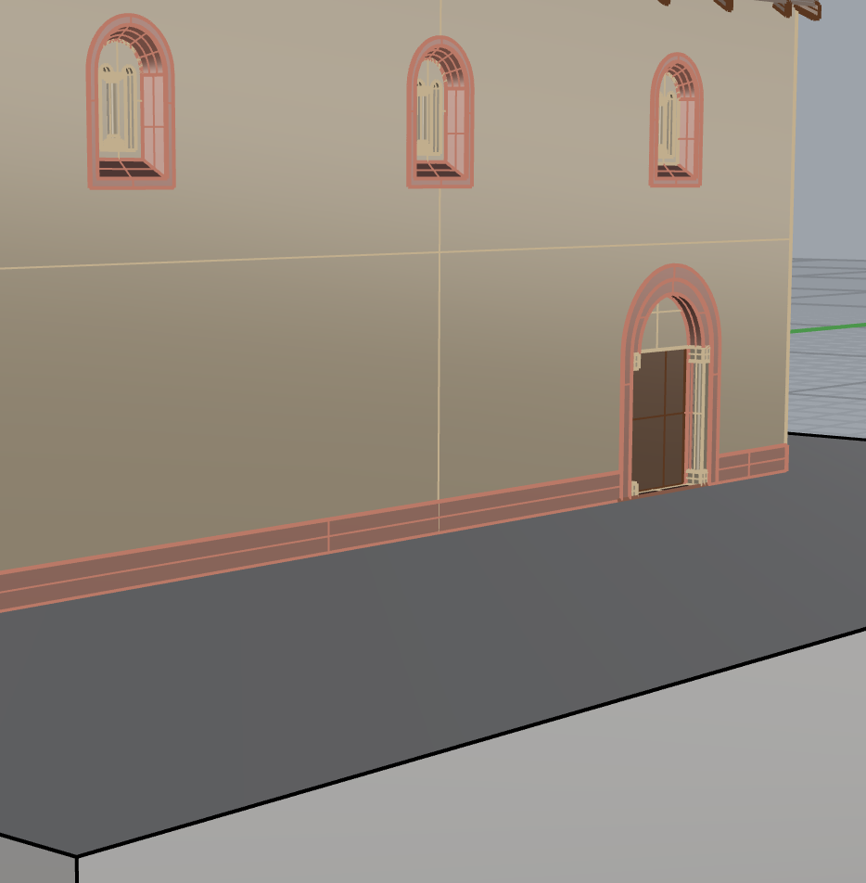
Used sources | Name of the source,  eg. Photo_location_01 | Screenshot of the source
 | Name of the source,  eg. Photo_location_02 | Screenshot of the source
Uncertainty | Argumentation | 03-deduction
Argumentation | Short description of the process of reconstruction with enlightening the challenging part of reconstruction of element

Floor

Reconstruction | 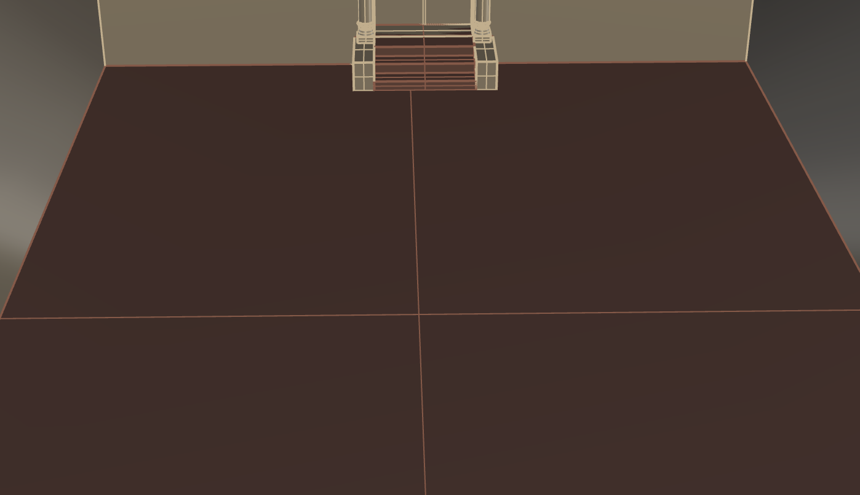
Used sources | Name of the source,  eg. Photo_location_01 | Screenshot of the source
 | Name of the source,  eg. Photo_location_02 | Screenshot of the source
Uncertainty | There are no traces of the ancient floor | 01-hypothesis
Argumentation | Short description of the process of reconstruction with enlightening the challenging part of reconstruction of element

Foundations

Reconstruction | 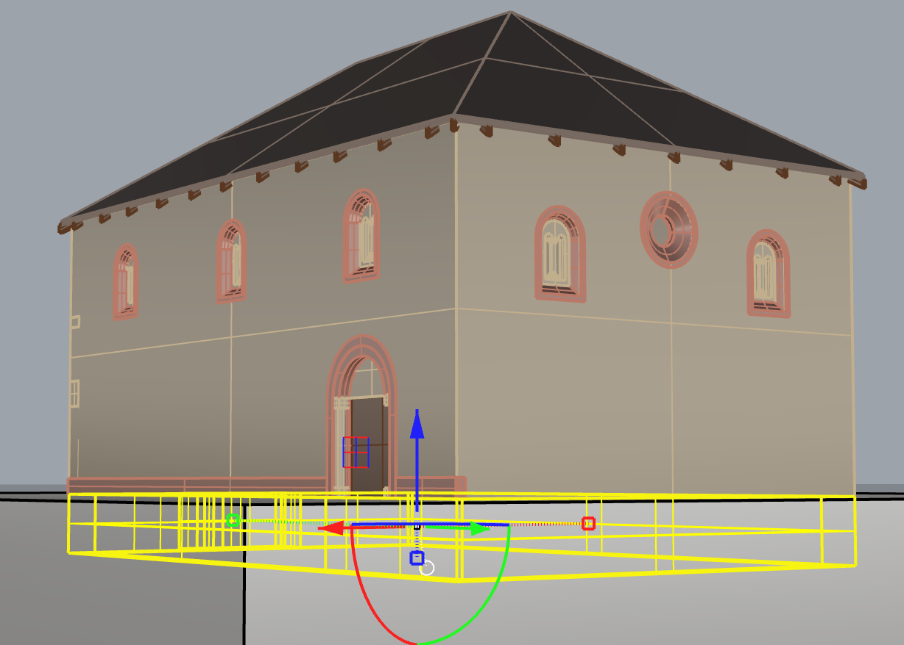
Used sources | Name of the source,  eg. Photo_location_01 | Screenshot of the source
 | Name of the source,  eg. Photo_location_02 | Screenshot of the source
Uncertainty | The foundations are still there and they were analysed during the archaeological excavations | 04-still existing
Argumentation | In the light of the used sources, it was decided to draw the element “foundations” with a depth of 1.5 metres.

